Course teaching survey:

# DB connection:

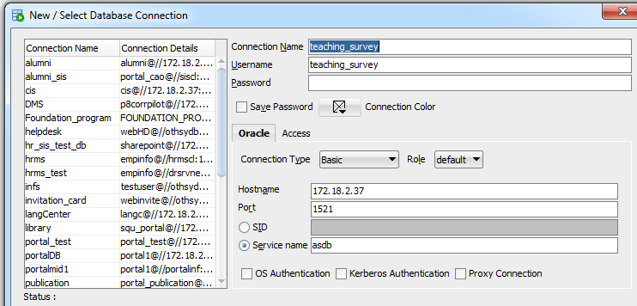

# First service:

## Course and teaching survey summary:

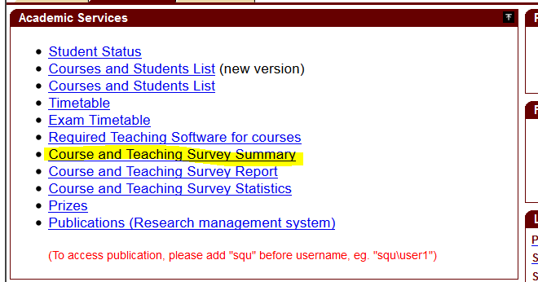

**This service shows for the faculty:**

* Page name” teaching_survey_academic_year_repShowPage.jsp”
* During survey period it shows
  + Course code
  + Course name
  + Section no.
  + Number of registered student in the course
  + Number of responses.
* Use the function “EVALUATE_COURSE” to show the courses that should be evaluated.
* Result of all surveys per academic year. Example 2014-2015
* If the faculty click on a specific academic year, he will get a list of all courses he taught in the two semesters fall and spring ( summer is excluded).

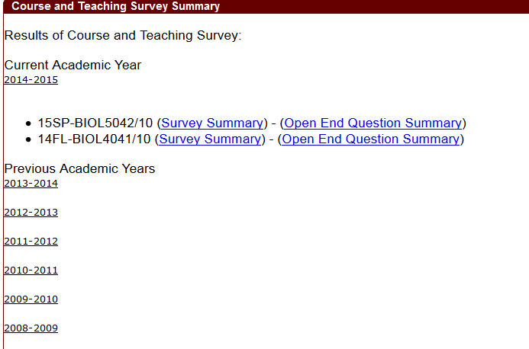

* **If he click on Survey Summary:**
* **Page name : TeachingAnalysisSurveyPortletShowPage.jsp**

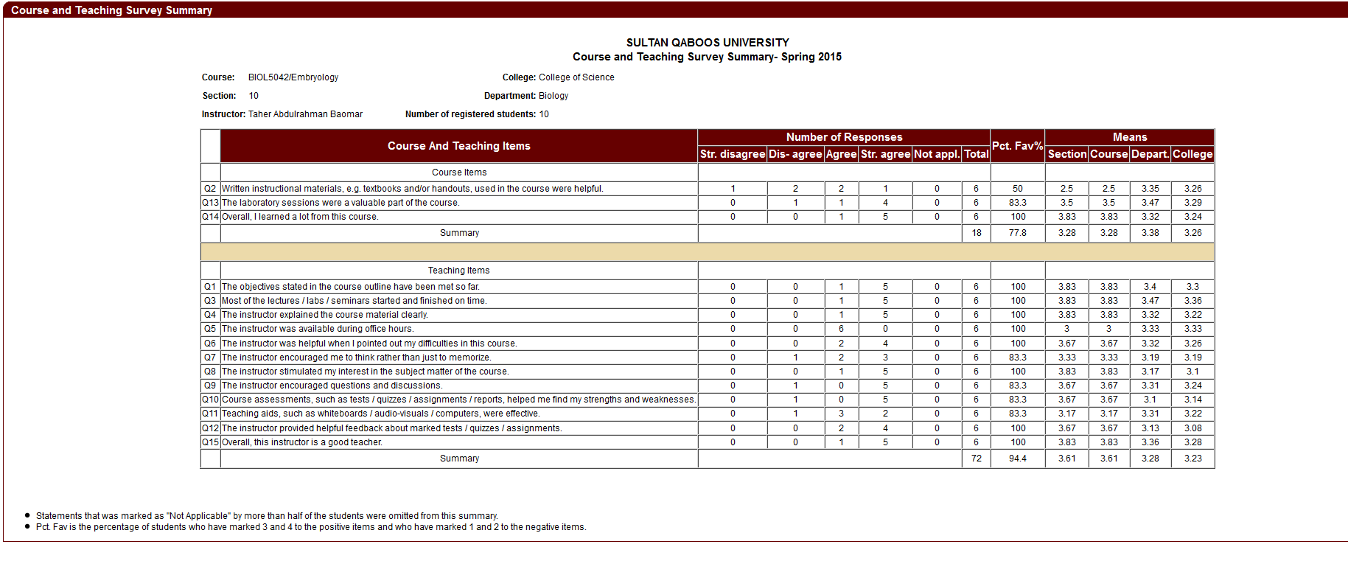

This page can be accessed also by the committee, dean and HOD we use the function ACCESS_TEACHING_SURVEY_REP to allow them to see this page.

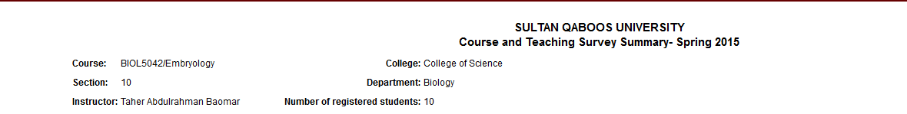



**If he click on open and End Question Summary: page name”** **Open_end_teaching_survey_result_portlet.jsp”**

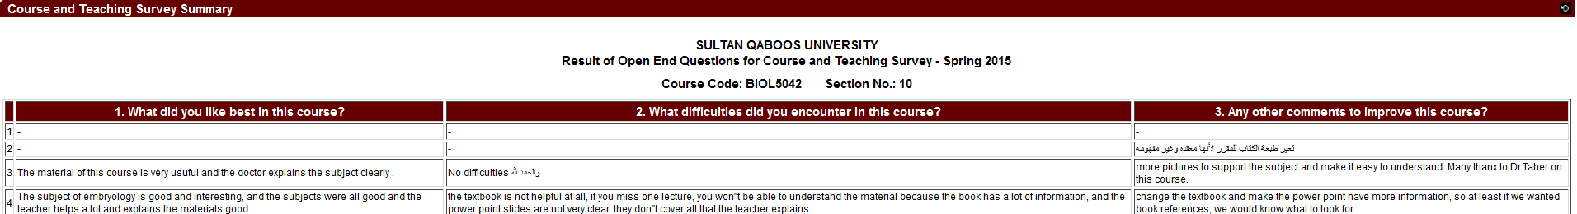

This page shown only by the faculty.

# Second Service:

## Course and teaching survey report:

* Only the committee member can view all reports.
* The dean can view his college and the HOD can view his department.
* The survey splitted into valid and invalid according to some rules using the function “course_survey_valid”
* Pages used:
  + teaching_survey_reports_portletShowPage.jsp
  + summary_result.jsp
  + TeachingAnalysisSurveyPortletShowPage.jsp

-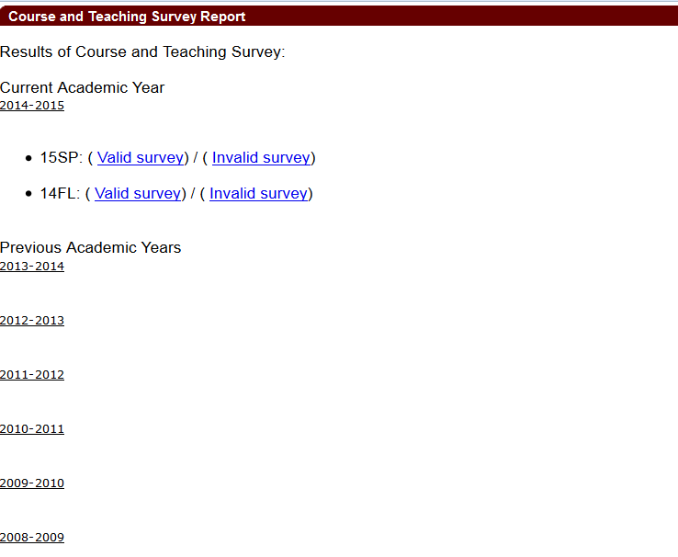

## Valid survey:

All valid surveys are ranked by university then college then department .

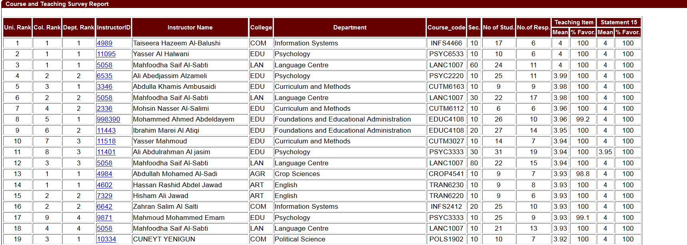

If the Instructor Id is clicked then the following page opened:

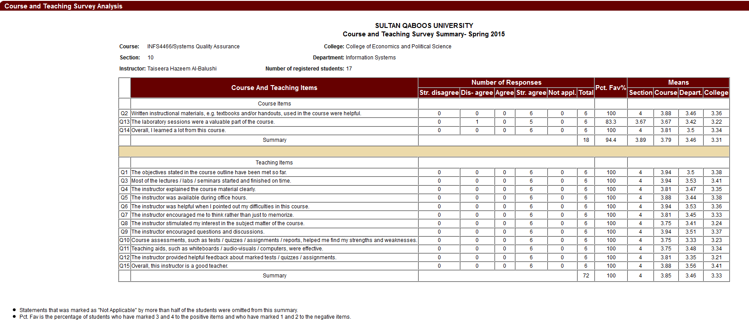

Invalid Survey:

Specify the rules why they are not valid in general

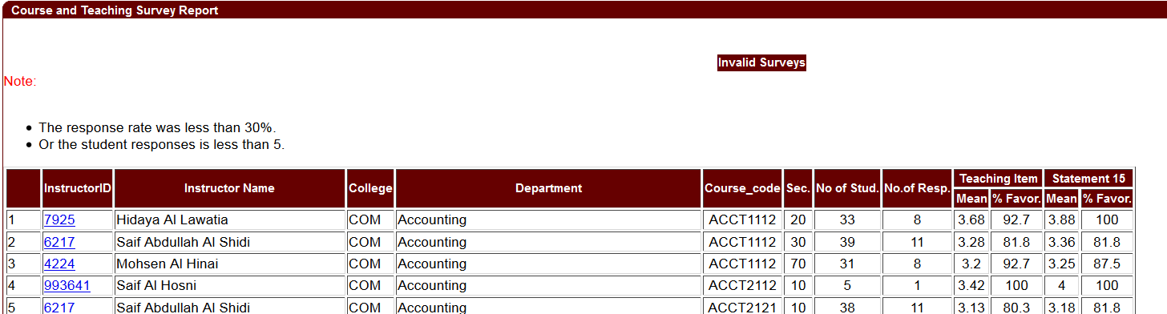

But when instructor id clicked, it will show why this survey is not valid in red:

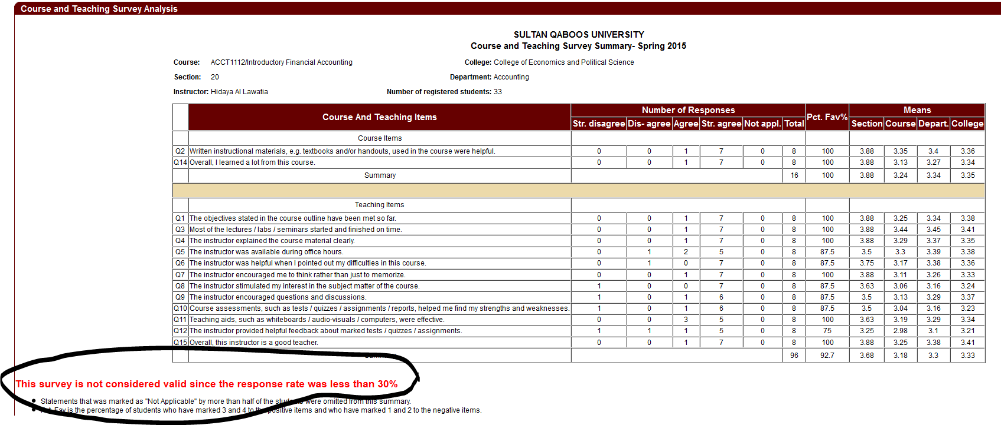

Note:

Clinical courses are showing in the form for the student to fill it but it is not included the result. So there is no summary for the clinical courses.